**Class Task**

1. Write a program to accept a number N and print

whether it is positive, negative or zero.

Source code :

import java.util.Scanner;

public class q1{

public static void main(String args[]){

int N;

Scanner n=new Scanner(System.in);

System.out.println("Enter number");

N=n.nextInt();

if(N==0){

System.out.println(" Zero ");

}

else if (N>0){

System.out.println(" Positive number ");

}

else {

System.out.println(" Negative number ");

}

}

}

Output:

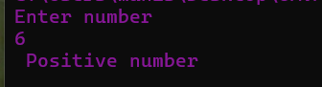

2.Write a program to accept two numbers and print the greater value of the two.

Source code :

import java.util.Scanner;

public class q2{

public static void main(String args[]){

int n1,n2;

Scanner n=new Scanner(System.in);

System.out.println("Enter number 1");

n1=n.nextInt();

System.out.println("Enter number 2");

n2=n.nextInt();

if(n1>n2){

System.out.println(" Number 1 is greater ");

}

else if(n1<n2){

System.out.println(" Number 2 is greater ");

}

else {

System.out.println(" equal ");

}

}

}

Output:

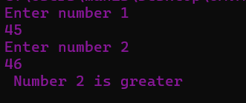

3. Write a program to accept a number N and print

whether the number is EVEN or ODD.

**Source code:**

import java.util.Scanner;

public class q3{

public static void main(String args[]){

int n;

Scanner a=new Scanner(System.in);

System.out.println("Enter number ");

n=a.nextInt();

switch(n%2){

case 0:

System.out.println("Even ");

break;

case 1:

System.out.println(" Odd ");

break;

default :

System.out.println(" nothing ");

}

}

}

**Output:**

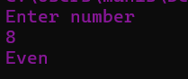

4. Write a program to accept two numbers and print whether their sum is EVEN or ODD

**Source code :**

import java.util.Scanner;

class q4{

public static void main(String args[]){

int n1,n2;

Scanner e=new Scanner(System.in);

System.out.println(" Enter number 1 ");

n1=e.nextInt();

System.out.println(" ENter number 2");

n2=e.nextInt();

switch((n1+n2)%2){

case 0:

System.out.println(" EVEN ");

break;

case 1:

System.out.println(" ODD ");

break;

}

}

}

**Output :**

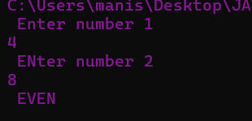

**Homework Task**

Q1. Write a Java program that takes three numbers from the user and prints the greatest number.

**Source code:**

import java.util.Scanner;

public class c1{

public static void main(String args[]){

int n1,n2,n3;

Scanner g=new Scanner(System.in);

System.out.println("Enter number 1");

n1=g.nextInt();

System.out.println("Enter number 2");

n2=g.nextInt();

System.out.println("Enter number 3");

n3=g.nextInt();

if(n1>n2 && n2>n3){

System.out.println(" The greatest :" +n1 );

}

else if(n3>n1){

System.out.println(" The greatest :" +n3);

}

else if(n2>n1) {

System.out.println(" The greatest : " +n2);

}

}

}

**Output :**

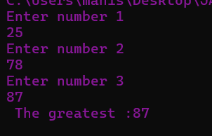

Q2.write a java program that reads a floating-point number and prints “zero” if the number is zero. Otherwise ,print “positive” or “negative”. Add “small” if the absolute value of the number is less than 1, or “large” if it exceeds 1,000,000.

**Source code:**

import java.util.Scanner;

public class c2{

public static void main(String args[]){

float f;

Scanner g=new Scanner(System.in);

System.out.println("Enter number ");

f=g.nextFloat();

if(f==0){

System.out.println(" zero" );

}

if(f<0){

System.out.println(" Negative" );

}

if(f<1) {

System.out.println("Small " );

}

if(f>1 && f<1000000){

System.out.println("Positive Number");

}

if(f>1000000){

System.out.println(" large ");

}

}

}

**Output:**

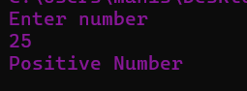

Q3. Write a Java program that reads two floating-point numbers and tests whether they are the same up to three decimal places.

**Source code:**

import java.util.Scanner;

public class c3{

public static void main(String args[]){

float f1,f2;

Scanner g=new Scanner(System.in);

System.out.println("Enter number 1 ");

f1=g.nextFloat();

System.out.println("Enter number 2 ");

f2=g.nextFloat();

if(f1==f2){

System.out.println( " Both are same ");

}

else{

System.out.println( " They are different ");

}

}

}

**Output:**

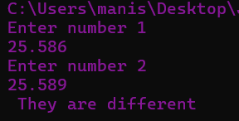

Q4. Write a Java program to find the number of days in a month.

**Source code:**

import java.util.Scanner;

public class c4{

public static void main(String args[]){

int m,y,d;

String n;

Scanner g=new Scanner(System.in);

System.out.println("Enter month ");

m=g.nextInt();

System.out.println("Enter year ");

y=g.nextInt();

switch(m){

case 1:

n="january" ;

d=31;

break;

case 2:

n= "February" ;

if(y%4==0){

d=29;

}

else{

d=28;

}

break;

case 3:

n= "March" ;

d=31;

break;

case 4:

n="Aril" ;

d=30;

break;

case 5:

n="May" ;

d=31;

break;

case 6:

n="June";

d=30;

break;

case 7:

n="July" ;

d=31;

break;

case 8:

n="August" ;

d=31;

break;

case 9:

n="Septemper" ;

d=30;

break;

case 10:

n="October" ;

d=31;

break;

case 11:

n="November" ;

d=30;

break;

case 12:

n="December";

d=31;

break;

default:

n="invalid";

d=0;

System.out.println(" Invalid month and year");

}

System.out.println( n+ " " +y+ " has " +d+ " days ");

}

}

**Output :**

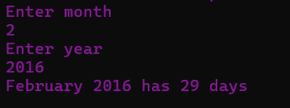

Q5. Write a Java program that requires the user to enter a single character from the alphabet. Print Vowel or Consonant, depending on user input. If the user input is not a letter (between a and z or A and Z), or is a string of length>1, print an error message.

**Source code:**

// task

import java.util.Scanner;

public class c5{

public static void main(String args[]){

char c;

String str;

Scanner g=new Scanner(System.in);

System.out.println("Enter any character ");

str=g.nextLine();

c=str.charAt(0);

if (str.length() > 1 || !Character.isLetter(str.charAt(0))) {

System.out.println("Error");

} else {

if (c == 'a' || c == 'e' || c == 'i' || c == 'o' || c == 'u' ||

c == 'A' || c == 'E' || c == 'I' || c == 'O' || c == 'U') {

System.out.println("Input letter is a vowel");

} else {

System.out.println("Input letter is a consonant");

}

}

}

}

**Output:**

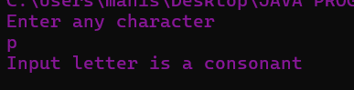

Q6. Write a Java program that takes a year from the user and prints whether it is a leap year or not.

**Source code :**

import java.util.Scanner;

public class c6{

public static void main(String args[]){

int y;

Scanner sk=new Scanner(System.in);

System.out.println("Enter year ");

y=sk.nextInt();

switch(y%4){

case 0 :

System.out.println( y+ " is a leap year");

break;

default:

System.out.println( y+ " is not a leap year");

}

}

}

**Output :**

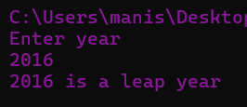

Q7. Write a program in Java to input 5 numbers from the keyboard and find their sum and average.

**Source code :**

import java.util.Scanner;

public class c7{

public static void main(String args[]){

int n1,n2,n3,n4,n5;

Scanner sk=new Scanner(System.in);

System.out.println("Enter Number 1 ");

n1=sk.nextInt();

System.out.println("Enter Number 2 ");

n2=sk.nextInt();

System.out.println("Enter Number 3 ");

n3=sk.nextInt();

System.out.println("Enter Number 4 ");

n4=sk.nextInt();

System.out.println("Enter Number 5 ");

n5=sk.nextInt();

int s=n1+n2+n3+n4+n5;

float a=s/5;

System.out.println("The sum of 5 no is : " +s );

System.out.println("The Average is : " +a );

}

}

**Output :**

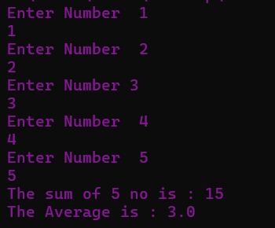

Q8. Write a Java program that displays the sum of n odd natural numbers.

**Source code:**

import java.util.Scanner;

public class c8{

public static void main(String args[]){

Scanner sk=new Scanner(System.in);

int n,i,o;

System.out.println("Input number of terms is :");

n=sk.nextInt();

int count=0;

int sum=0;

for(i=1; count<n ;i++){

if(i%2!=0){

System.out.println(i);

sum=sum+i;

count++;

}

}

System.out.println("The sum of odd natural number upto " +n+ "terms is " +sum);

}

}

**Output:**

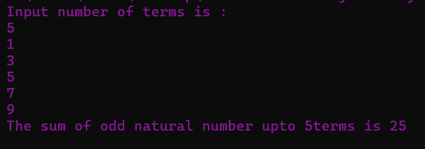

Q9. Write a program that accepts three numbers from the user and prints “increasing” if the numbers are in increasing order, “decreasing” if the numbers are in decreasing order, and “Neither increasing or decreasing Order” otherwise.

**Source code:**

import java.util.Scanner;

public class c9{

public static void main(String args[]){

int n1,n2,n3;

Scanner g=new Scanner(System.in);

System.out.println("Enter number 1");

n1=g.nextInt();

System.out.println("Enter number 2");

n2=g.nextInt();

System.out.println("Enter number 3");

n3=g.nextInt();

if(n1>n2 && n2>n3){

System.out.println(" Decreasing order " );

}

else if(n3>n2 && n2>n1){

System.out.println(" Increasing order " );

}

else {

System.out.println(" Neither increasing nor decreasing ");

}

}

}

**Output :**

